**The Human Aided Dispersal of the Emerald Ash Borer and the Associated Risks in Minnesota**

Caleb Mackey

Geography 678

Thesis Proposal

12/6/2014

# **Abstract**

The Emerald Ash Borer, *Agrilus planipennis* Fairemaire (Coleoptra: Buprestidae), is an invasive species that has killed millions of ash trees (*Fraxinus* spp.) since it was discovered in North America in 2002. This pest kills ash trees by feeding on the phloem and cambium of ash trees which cuts off the nutrient supply from the roots to the crown usually resulting in death within 3-6 years. This study will use a predictive model known as SHIFT (Prasad et al. 2010) to estimate the future risk of spread in Minnesota by combining their natural flight potential (“insect flight”) with human aided dispersal (“insect ride”). The SHIFT model uses GIS analysis to combine wood product industries, population densities, major roads and traffic counts, and campground information in conjunction with ash basal area to estimate areas of infested cells. The model outputs will be tested against a current estimate of occupied forest stands derived from insect trap counts, ash habitat, and natural flight patterns. This study will also include an in depth study of wood industries in Minnesota through questionnaires as well as human activities and land use patterns that may be contributing the rapid movement of this pest.

# **Introduction**

The emerald ash borer (EAB), *Agrilus planipennis* Fairemaire (Coleoptra: Buprestidae), is an invasive species that has killed millions of ash trees (*Fraxinus* spp.) since it was discovered in North America in 2002. Because these beetles spend most of their life as larvae feeding on the inner vascular tissue of ash trees, most of their movement can be accredited to unintentional human transportation of infested wood. Therefore, a better understanding of the human processes and patterns that are contributing to the distribution of the emerald ash borer is necessary to help slow and hopefully stop the spread of this invasive species in the United States and Canada.

Most of the previous research regarding the EAB has been focused on the biology, ecology, quarantine efforts, adverse effects on ash trees, and woodpecker or wasp predation on the beetle as a biological control agent. However, there are only a few studies on the human transportation of infested wood. This is probably due to the complex nature of the human facilitated dispersal of this pest and all the possible modes of transportation. Prasad et al. (2010) identified some of the probable sites and activities that transport infested ash wood such as sawmills, transportation of infested wood along major highways, tree nurseries, wood harvesting centers, and human population centers. Of course, the most important factor for the establishment of the EAB in a given area is dense ash tree populations.

The first confirmed Minnesota emerald ash borer infestation was discovered in the South Saint Anthony neighborhood of St. Paul on May 14th, 2009. Not long after, additional sites were found near Winona and Rochester (Minnesota Department of Agriculture). These appear to be outlier sites from the current EAB distribution in North America and are most likely a result of human aided dispersal. The purpose of this study will be to answer two research questions by focusing on the colonized sites in Minnesota. The first question is how dense are the EAB populations at these sites right now? The second question to address is how human transportation has enabled this pest travel to Minnesota, and where might it travel next through these same means of travel? This study will attempt to identify if there are certain sites that received deliveries of infested wood that can be linked to areas of known infestations in the past. This study hypothesizes that there are specific ash transportation patterns, wood harvesting businesses, and land uses that can be linked to the current distribution of the emerald ash borer in Minnesota.

In order to answer these research questions, three phases of research will need to be conducted. To address the current state of EAB populations in Minnesota, sampling will be done to estimate the populations and to judge the severity of the infestations (phase 1). Phase 2 will use the spatially explicit cellular model outlined by Prasad et al. (2010) to find correlations with the predicted EAB spread in Ohio and the current distribution of the EAB in Minnesota. This will help to determine the validity of the model and possibly identify areas of improvement. Phase 3 will involve gathering data from tree nursery workers, sawmill workers, and other applicable parties through the use of questionnaires near the infested areas of Minnesota in an attempt to trace where infested ash wood came from and where wood products are exported from this area. This data will be combined with the spatially explicit cellular model and GIS analysis techniques to predict where humans may inadvertently transport infested wood in the future. This research will be useful for determining human-specific patterns for the dispersal of the emerald ash borer. If we gain a better understanding on the spatial dynamics of this pest’s distribution, it could lead to better quarantine efforts and possibly better regulation of potentially infested wood.

## **Literature Review**

Since its introduction to North America, the emerald ash borer has spread across 15 U.S. states and two providences in Canada, killing millions of ash trees in the process. North America’s ash trees are far more susceptible to this foreign pest because it lacks the natural enemies and defensive traits of their Asian counterparts (Rebek et al. 2008). Efforts to control this problem have been very expensive for government and environmental agencies alike. To further complicate things, *A. planipennis* movement is very difficult to track because most of the insect’s lifecycle takes place in the inner tissue of ash trees. This makes the larvae more evasive, providing a means of unintentional human aided dispersal through ash wood product transportation (Cappaert et al. 2005).

### **Biology and Life Cycle**

The Emerald Ash Borer was first discovered in North America near Detroit, MI and Windsor, Ontario in 2002 (Anulewicz et. al 2008, Poland and McCullough 2006). Several specimen were brought to the Department of Entomology at Michigan State University that were collected from dying ash trees in the greater Detroit area. The faculty of the Entomology Department determined that the specimens were likely the genus *Agrilus*, and they were later positively identified as *Agrilus planipennis* by Dr. Eduard Jendek of Slovoka. This marked the first time it was identified outside of its native host range in Asia (Poland and McCullough 2006).

At the time of the emerald ash borer’s introduction to North America, very little was known about the beetle. In fact, prior to 2003, even in its native range in Asia few studies were conducted on the biology and ecology of *A. planipennis* because it there were few areas where it was causing significant damage (Siegert et al. 2010; Wang et al. 2010). It was because of the more recent and severe ash mortality rates of *F. velutina* (velvet ash) in Tianjin, China that necessitated the need for a better understanding of this pest (Wang et al. 2010). The native range of the EAB is China, Japan, Korea, Mongolia, eastern Russia, and Taiwan, but studies have shown that they generally only attack stressed trees because the Asian ash are more resilient as a result of coevolution (Anulewicz et. al 2008).

The EAB is a member of the order Coleoptera (beetles) and is in the Buprestidae family, which are the wood boring beetles. The life cycle of *A. planipennis* spans from one to two years, depending upon the temperatures of the infested region. The two year life cycle tends to occur in the northern parts of the North American host range in Michigan, New York, and parts of Canada where the larvae will spend a second winter season to mature, feeding on the phloem and cambium in a pre-pupae state through four instar stages (Marshall et al. 2010). The adult form of *A. planipennis* is small, usually less than ten millimeters long and approximately two millimeters wide. Their bodies are elongated in the shape of a bullet with bronze to gold coloring on their abdomen with metallic emerald colored wing covers.

The adult beetles do not cause significant damage to ash trees as they usually feed on the leaves and mate on the bark of the trees. Instead, it is the larvae that effectively girdle the trees during the winter months, essentially cutting of the nutrient supply from the roots to the crown of the tree. During the mating season, females lay their eggs on the bark and in between crevasses on the outer surface of trees. Oviposition typically occurs in mid-May in the native range of the EAB (Wang et al. 2010) and in June to early July in North America (Poland and McCullough 2006). The females will lay eggs under the bark or in cracks and the larvae will usually hatch within two weeks and start boring into the phloem of the tree (Anulewicz et. al 2008). Each female will typically lay between 50-90 eggs during her lifecycle (Poland and McCullough 2006). Research has shown that some females will lay eggs on trees other than ash but the larvae will often not survive in non-ash trees (Anulewicz et. al 2008; Rebek et al. 2008).

When the eggs hatch, the larvae emerge as a creamy white wormlike organism and begin chewing through the inner tissue right away. In the first few months, the instars in their pre-pupae state will form shallow serpentine tunnels in the phloem and cambium of the trees leaving behind a trail of frass, which is a brown woody excrement. The larvae mature through four instars in their pre-pupae form by feeding on phloem during the fall, and then move deeper into the sapwood to form overwintering chambers. In the early spring, the larvae will transform into sexually mature adults and emerge from the trees leaving D-shaped exit wounds.

### **Ash Trees and Economic Impacts**

Since the EAB arrived in North America in 2002, millions of ash trees have fallen victim to this invasive species. In fact, by 2006, it was estimated that over 100 million ash trees had been attacked or killed by *A. planipennis*, with over 20 million ash fatalities in Michigan alone (Anulewicz et al. 2007). Once an ash tree is attacked, it will usually die within two to four years depending on the larval density. This process is known as slow ash mortality (SLAM, McCullough and Mercader 2012). By the time the tree has dense a larval population, the tree will already have visible signs of declining health (Wang et al. 2010). Other more obvious visual cues of an EAB attack are crown dieback, epicormic shoots, and bark flaking.

Ash trees are a hardwood species that are very common in North America, Canada, and China. They are a member of the genus *Fraxinus* in the order *Lamiales* and the family *Oleacea*. The trees most commonly attacked in North America are white ash *(F. americana*), green ash (*F. pennsylvanica*), blue ash (*F. quadrangulata*), black ash (*F. nigra*), and pumpkin ash. (*F. profunda,* Anulewicz et. al 2008; BenDor et al. 2006). They are medium sized trees with average heights reaching 50-80 feet at the top of the crown and tend to colonize gaps in older hardwood forests. Ash trees are also very common ornamental shade trees in urban settings because they are fast growing woodland trees that are used to line streets (Poland and McCullough 2006). Ash trees are especially abundant in urban settings in Michigan, Chicago, and New York comprising approximately 15-20% of all urban tree species (BenDor et al. 2006).

Future ash tree perseverance in forest stands that have been heavily infested with the EAB will depend on the potential for regeneration (Klooster et al. 2013). This can be problematic for ash tree survival because the beetles will feed on trees as small as 2.5 cm (McCullough et al. 2008; Rebek et al. 2008; Klooster et al. 2013) and some ash species take up to 60 years before they are mature enough to produce seeds (Kurmis and Kim, 1989; Klooster et al. 2013). The regeneration of ash trees in forested areas is unlikely when ash mortality is high in the aftermath of an EAB invasion and will depend on the resilience and reproduction of an “orphaned cohort” of the ash seedlings and saplings that had previously occupied the area. Michigan has experienced this seemingly irreversible ash mortality according to this theory. By 2007, ash mortality topped 90% from the rapid spread of *A. planipennis* in Michigan, which nearly decimated the ash seed bank. Within the next two years, a small number freshly germinated ash seedlings remained and only the earlier established ash seedlings and saplings survived in Michigan’s forests as ash mortality rates soared to over 99% (Klooster et al. 2013).

With the high rates of ash mortality as a result of the EAB invasion in North America, there is bound to be significant economic impacts in urban settings. Sydnor et al. (2007) attempted to quantify the economic impacts of the EAB threat to the state of Ohio’s urban ash resource. Based on a study of 200 Ohio communities, they estimated that median based losses in landscape value from urban ash mortality was $0.8 billion and the mean based loss at $3.4 billion. This assumes the complete loss of ash trees within the city limits and includes costs associated with ash treatment and replacement. They also determined that a more cost effective solution would be removing the infested trees without replacing them which would result in losses of $0.7 billion and $2.9 billion for the median and mean losses in all cities.

### **Dispersal and Detection**

The EAB has infested 15 states across the Midwest and north eastern U.S. since it was discovered in 2002 (Figure 1). The infestation has also traveled north, occupying the two Canadian Provinces of Ontario and Quebec (Vannatta et. al 2012, Anulewicz et al. 2007; Poland and McCullough 2006). *A. plannipennis* was likely introduced to the U.S. through international trade by use of wood crates and pallets. Through this means of transportation, the EAB was able to thrive and became an established invasive species by feeding on the abundant source of ash trees in Michigan (Poland and McCullough 2006).

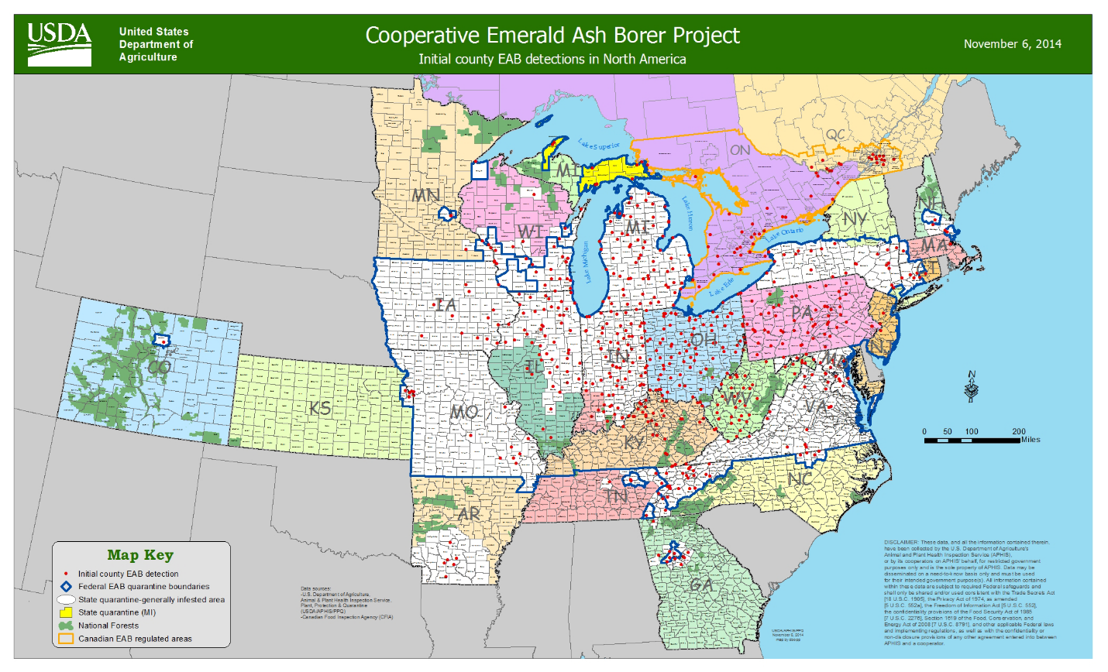**Figure 1. Current EAB Distribution (USDA APHIS)**

Because the EAB live most of their life as larvae inside the trees it can often take several years for larger trees to show signs of stress from attacks, this presents a challenge to discover and control this pest (Wang et al. 2010). This is also problematic for identifying quarantine areas and why so much infested ash is transported by humans unknowingly. Some of the likely factors contributing to the human aided transportation of infested ash wood are sawmills, ash tree densities, major highways, tree nurseries, wood harvesting centers, and human population centers (Prasad et al. 2010). There are a lot of unknowns about the human transportation of the EAB because it is such a difficult problem to dissect. There are countless factors that could influence the “insect ride” dispersal, so predictive statistical modeling of this type of spread is more common than empirical evidence. This is due to difficulties in tracking the movements of the EAB and identifying infested trees, which is nearly impossible without the presence of epicormic shoots, D-shaped exit wounds, or canopy dieback. It has been estimated that insect populations are moving at a “front” of approximately 20 km per year (Prasad et al. 2010).

The research has shown that there can be significant economic impacts from the destruction of North America’s ash resource and therefore it is imperative to develop methods to control and eradicate this invasive species. Research geared towards early detection could be crucial to setting up quarantine zones and slowing the spread of the emerald ash borer. Insect traps have become a popular tool for monitoring the EAB and see what attracts adult beetles to ash trees. Purple prism traps can often be a visual cue for identifying a quarantine area and are commonly used in Michigan and New York where there are dense EAB populations. These traps can also help to warn individuals that any wood removed from these quarantine areas will likely need treatment to kill any potential larvae that could be inside the logs.

Marshall et al. (2010) conducted a study to observe different trap types to test efficacy of several olfaction lures in trapping EAB adults. There were 68 total study sites tested in Michigan, Ohio, Indiana, and Pennsylvania where unscented and scented traps of different colors were set up at all sites. The 5 types included: (1) green prism traps with phoebe oil lure were used, as well as green prism traps with no lure as a control (2); (3) purple prism traps were baited with a phoebe and manuka oil (4); and a non-baited purple trap (5). These oils are what give off the scent of a stressed ash tree. Study sites were set up in suspected low density sites (≤ 2 infected trees per site). Of the 68 study sites, 27 of the areas did not capture any EAB specimens. A total of 33 test sites showed signs and symptoms of having EAB attacks and had a density of ≤ 2 infected trees per site with a total 64 EAB captured. Of these sites, only 14 had symptoms that were easily identifiable upon a visible inspection. Eight test sites showed high density of the EAB populations and the trees showed signs of considerable damage with a total 300 EAB specimens captured.

The results of the study showed that the purple prism traps with manuka oil were the most effective in luring and trapping adult beetles. The purple coloring of traps appeared to be an effective visual cue while the manuka oil lured the beetles to the trees. Manuka oil mimics the scent of a stressed ash tree because it contains volatile sesquiterpenes that are present in ash bark (McCullough et al. 2009). Out of all the traps set, 80% of the purple prism traps captured adult beetles, whereas only 47% of the green prism traps were able lure in adult beetles. Key factors for the success of traps were the location of the tree, canopy thickness, and dominant tree species within each forest stand.

## **Study Area**

This study will encompass the entire state of Minnesota for the predictive risk of spread modeling (SHIFT model explained in Methods section), while the study areas for the insect traps will be in the quarantine areas near standing infested trees. The two areas for insect trap locations will be focus in the infestation area in Southeastern Minnesota between the cities of Winona and Dakota (Figure 2) and in the Twin Cities area (Figure 3).

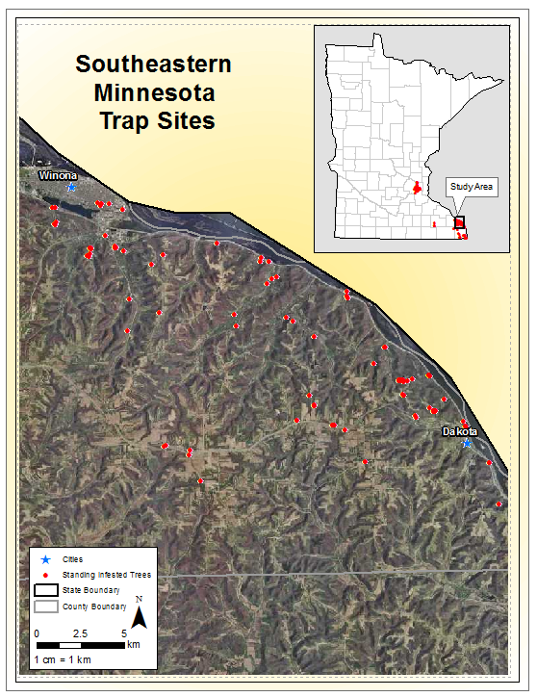**Figure 2. Figure Southeastern Minnesota Study Area**

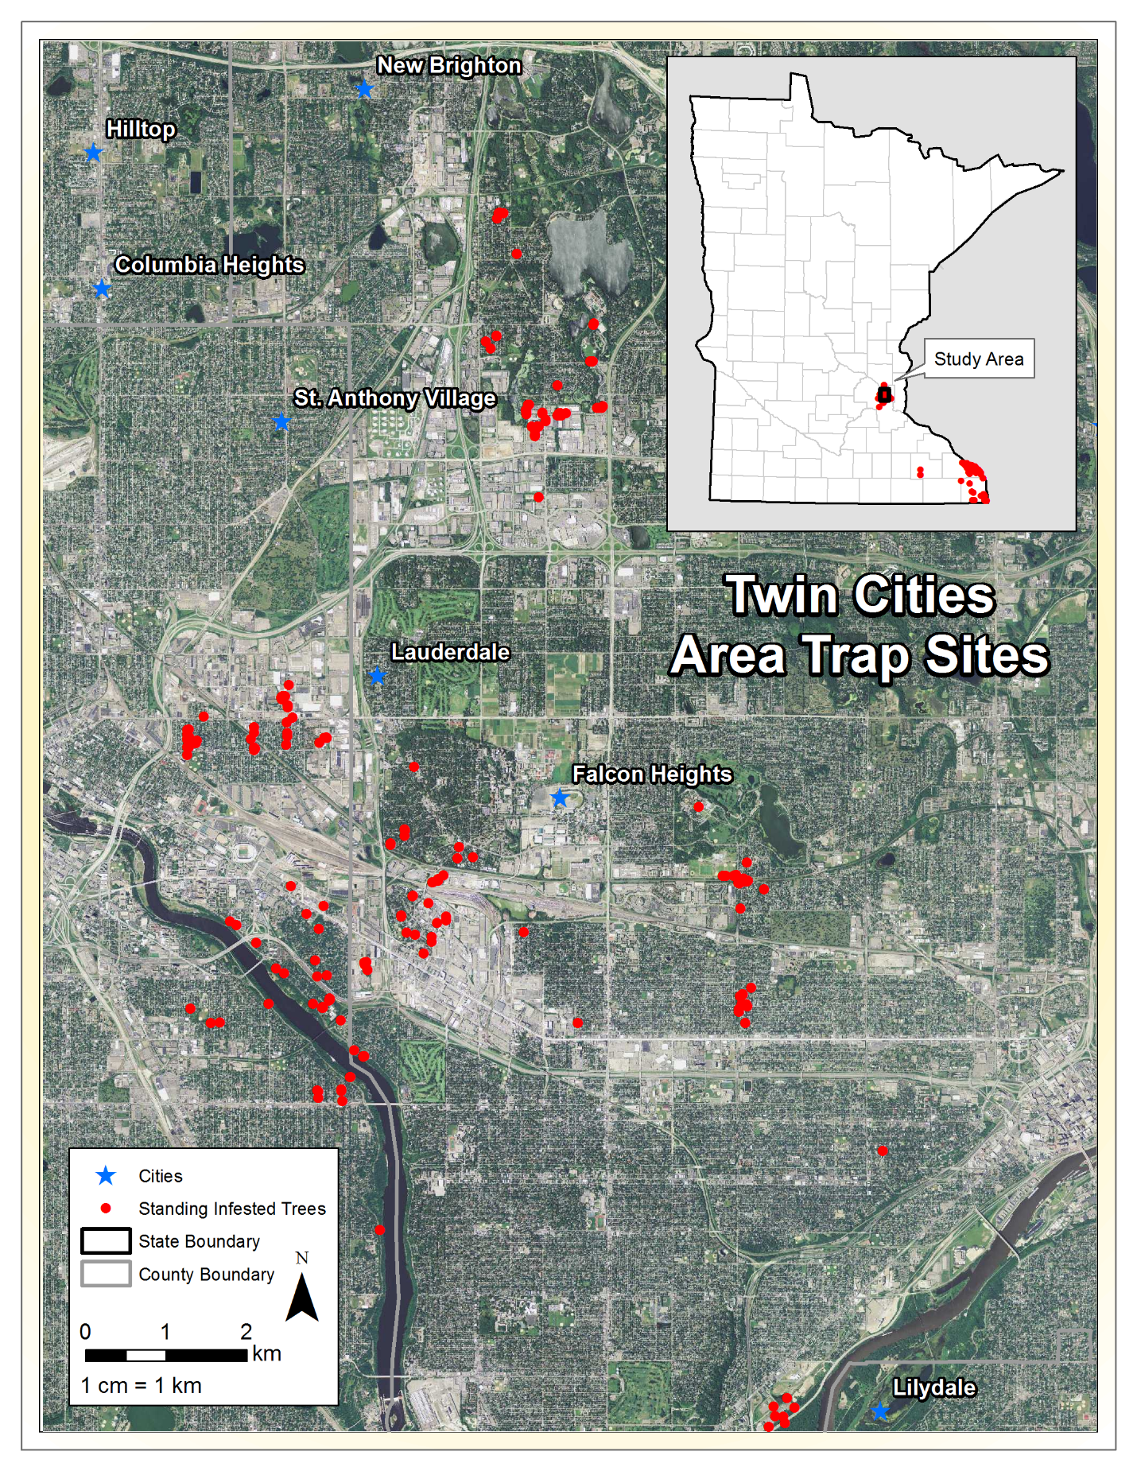

**Figure 3. Twin Cities Study Area**

# **Methods**

There will be three phases to the methodology. To address the first question of the current estimates of the insect populations in Minnesota, field work will be conducted to sample adult beetles at the Southeaster Minnesota and Twin Cities sites. To gain a better understanding of where infested ash wood is being imported from near the three study areas, survey forms will be sent to 50 different entities who harvest ash wood in Minnesota. Finally, to investigate the dispersal in Minnesota, the spatially explicit cellular automata methods (SHIFT model) outlined by Prasad et al. (2010) will be used to predict where the EAB will colonize in the future. Some additional GIS analysis will look for correlations between specific businesses and human activities and the present distribution in Minnesota.

## **Insect Population Sampling**

A total of 12 purple prism traps will be constructed and baited with manuka oil will be used in an attempt to estimate current EAB populations in Minnesota based on the current standing infested tree database provided by the Minnesota Department of Agriculture. These will be constructed from wood and will be coated with Tangle-Foot Coating. Tangle-Foot coating is an insect adhesive that is designed for insect trapping and monitoring. Each trap will be hung at approximately six meters high on a stressed ash tree to attract as many adult beetles as possible.

Four traps will be placed at each of the three study areas and will be visited once per week to count adult EAB’s during the months of May-August. Traps will be placed within a 20 km radius of the infestation epicenter at each site and will be left in place for a period of 3-4 weeks during the summer months. The count data will be stored in an ArcSDE SQL Server Database using a mobile device and an ArcGIS Online Collector Application. This process will be repeated for two consecutive summers to add a temporal aspect to the study. By doing this for two consecutive years, I may also be able to determine if the insect populations are growing in these locations.

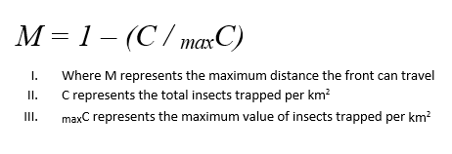 Once all the insect trap counts have been documented, the data will be prepped for later use as a control and validation for the SHIFT model results. As pointed out by Pretovskii et al. (2012), it is very challenging to derive accurate insect population estimates due to the stochastic nature of insect movement described in terms of Brownian motion. Therefore, this study will use the assumption that areas with higher trap counts per km2 mean there is a more stable population and for that reason the population can move at a front of 20 km per year. Since the data collected in this study only has a temporal resolution of two years and because trap counts alone are not good indicators of the overall population, the “control” areas that will be used for SHIFT validation will be relative to the distribution of trap count data. What this means is that the maximum distance of 20 km a front can travel will only be applied relative to the maximum trap count per km2 and everything in between the minimum and maximum trap counts will become a multiplier of the 20 km threshold between 0-1 to create a maximum distance threshold for each front (Figure 4).

**Figure 4. Maximum Distance Threshold**

This data will summarized and clipped within a moving window and be clipped to forested areas and a fuzzy classification will be used to determine probability of EAB infested cells within each moving window (i.e. areas with highest trap counts per km2 will have a max distance of 20 km where EAB may be found). This will yield a raster with probability values between 0-1, where 1 represents a %100 probability of EAB infestations in each cell (Figure 5). This is done to take the one dimensional point data of infested trees into a two dimensional surface.

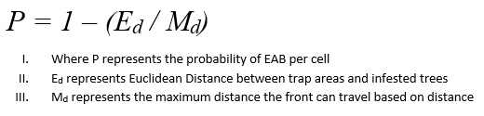

**Figure 5. Probability Raster for Current Infested Cells**

## **Ash Import and Export tracking**

In order to help paint the picture of how infested ash wood has made its way into Minnesota, 50 wood product industries will be studied within the areas of infestation. The benefits would be to gain a better understanding of where infested ash wood has been shipped from and then those locations will be investigated against the current distribution of the EAB in North America to see if there are infestations in those areas. Tree nurseries will also be investigated to see where ash wood gets shipped to in order to make determinations on where future spread may occur in Minnesota.

To collect this data, questionnaires will be sent to 50 wood product industries and nurseries and will include questions regarding from where imports are received, how much of the wood is ash, whether or not the wood is treated if it comes from areas where there are known EAB infestations, and if they export wood products. Once all the questionnaire data has been gathered, all locations will be mapped as well as locations where wood products are shipped to. Each wood industry will be given a rating for the likelihood that ash wood is used on site. The ratings will be decided by results from the questionnaires and by looking up standard industrial classification (SIC) codes available from the Dunn and Bradstreet database (<http://siccode.com/en>, Prasad et al. 2010). This data will be used in spatially explicit cellular model discussed in the next section.

## **Spatially Explicit Cellular and GIS Analysis**

Since much of the EAB’s movements can be attributed to human transportation of ash wood, a spatially explicit cellular mode known as SHIFT will be used to model the risk of spread in Minnesota. This model was modified by Prasad to combine both the natural flight potential (“insect flight”) of the EAB and the human aided dispersal (“insect ride”). The SHIFT model uses raster analysis to model risk of spread from occupied (infested) cells to unoccupied (new territory) for the EAB based on insect populations, ash abundance, and distance between occupied and unoccupied within a search window (Prasad et al. 2010). The risk equation is:

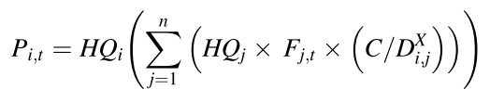**Figure X. SHIFT Model Equation (Prasad et al. 2010)**

Where Pi,t is the probability of unoccupied cell *i* being infested at a certain time *t*; *HQ*i and *HQ*j are the habitat quality/ash abundance scalars at unoccupied cell I and occupied cell *j* which represent the total basal area of ash (m2/ha) in each cell; *F*j,t is the estimated EAB abundance scalar between 0-1 in cell *j* based on the number of years since the infestation was discovered at time *t*; *D*i,j is the distance between unoccupied cell *i* and occupied cell *j*; and n is the number of cells in the neighborhood. The value for *C*, is a constant that will represent the 20 km dispersal rate of the EAB per year. The value *X* is the dispersal exponent that represents dispersal decay as the distance increases.

The end result of this model will be cells with an infestation probability between 0-1 for all cells, where a value of 1 represents a 100% probability of infestation at the cell. This is derived from summing all the occupied cells at each generation which can cause some unoccupied cells near many occupied cells to have a value greater than 1. For all values less than 1, a random number between 0.25 and 1 will be chosen and any value that is greater or equal to that value is becomes infested at that iteration of the model to add random dispersal to the model.

In order to calculate risk for the insect ride model, the SHIFT model is modified slightly to increase the *C* value to 400 km and different GIS data sets will be used as weights for multipliers for the ash basal area. The four weights that will be used will mirror those used by Prasad et al. (2010) which are traffic/major roads data, wood products industries and nurseries, population density, and campgrounds. Wood industries derived from the questionnaires will receive a maximum weight of 10% when there are more than 50 employees as regulations around these areas for quarantine are becoming stricter. Population density will receive a max score of 10% where population densities are at least 4,000 people/km2. Campgrounds will receive a max score of 20% when there are over 600 sites present. Finally, traffic and major roads data will receive the highest weight with a max score of 60% when there are daily traffic counts reaching 164,000 cars per day. It was determined that this should be the greatest weight because it provides the quickest mode of transportation for the EAB because 84% of all newly infested sites in Ohio were located within 1 km of a major road (Prasad et al. 2010).

In order to test the accuracy of SHIFT model, I will also use the fuzzy probability raster created from the trap counts, maximum distance thresholds, and ground truth data provided by the Minnesota Department of Agriculture of standing infested tree. In order to determine ash basal area estimates, forest inventory and analysis (FIA) data will be used with a Landsat TM classification of forest types to create a total ash basal area in m2/ha. The final output will be a risk of spread map for the state of Minnesota. Finally, both the SHIFT model outputs and the current predictions for the EAB distribution in Minnesota will be compared with land use data for Minnesota to see if there are any correlations with specific land uses and EAB infestations.

# **Expected Results**

The insect trap counts should provide insight to current insect populations where there are known infestations in Minnesota. There should be an increase in trap count finds in year two compared to the count data that will be collected in year one. Denser populations are also expected at farther distances from core infestation areas. I believe there will be higher trap counts in the Winona area as there is likely a greater abundance of ash trees due to more forested area.

The results from the questionnaires should identify areas in Minnesota that may pose future threats for ash destruction. These questionnaires will also help identify more wood product industries that may have infested wood because exports are tracked. The questionnaires will provide insights to what each business does with the wood and any treatments that occur on site and will be beneficial to the ranking process for vehicles of transport for this pest. Finally, this should help find patterns in human activities that are contributing to the spread of the EAB.

The SHIFT model should identify areas where there is a risk of EAB spread. This data should also correlate with the probability raster estimates of current infested cells and I expect that at least 50% of the current infested cells will be identified in the SHIFT model. By comparing this to ground truth data, this will validate the efficacy of SHIFT model.

# **Discussion and Conclusion**

The overall purpose of this study is to gain a better understanding of EAB populations in Minnesota, predict where future spread may occur, and see if there are patterns in land use and human activities that are helping this pest move around. Through setting up insect traps, researching wood industries, and applying GIS analysis techniques in a mathematical model, I believe this study will be beneficial to providing a better understanding of the EAB movements.

The insect trap counts will hopefully identify areas of dense beetle populations. By using two years of data, this also adds a temporal aspect in the observation of the EAB in Minnesota. In these areas of high EAB density, better quarantine efforts and restrictions may need to be put in place to slow down the pest’s dispersal in Minnesota. Since ash trees are very common in Minnesota, there are many areas that would be prime habitat for established EAB colonies and I expect that there will be correlations with ash density and trap counts.

The SHIFT model is well equipped for the goals of this study in trying to identify human activities that are facilitating the movement of the emerald ash borer because it incorporates wood product industries, major roads and traffic data, campgrounds, and human population density. This model is also advantageous because it combines both insect flight and insect ride movements. However, it is important to note that by testing the predicted infested cells by the SHIFT model against the output of the current EAB infestation area estimates, the validation is best suited for the insect flight movement. This is because the current EAB infestation probability raster is based on trap count information and the movement of the population front with a maximum travel distance threshold of 20 km based on insect flight. This may show where there is room for improvement in the SHIFT model as there are still many unknowns about the insect ride movement.

With the rapidly growing dispersal of emerald ash borer in the U.S. and Canada, new methods for early quarantine and protection need to be developed. There is some literature on using hyperspectral remote sensing for early detection of stressed ash trees, but this is expensive and may be difficult to apply to large areas. If shown to be reliable, I believe that the SHIFT model may be a better alternative for setting up quarantines in high risk areas before the EAB is able to colonize. In addition to providing validation to the SHIFT model, this study also hopes to make correlations with land use and human activities that are helping this pest spread through research of wood product industries and with comparisons to land cover data. If we can gain a better understanding about how this pest moves, more preventative measures can be taken to help slow the movement of this invasive species in Minnesota and the US.

# **References**

Anulewicz, A. C., McCullough, D. G., & Cappaert, D. L. (2007). Emerald ash borer (Agrilus planipennis) density and canopy dieback in three North American ash species. *Arboriculture and Urban Forestry*, *33*(5):338–349.

Anulewicz, A. C., Mccullough, D. G., Cappaert, D. L., & Poland, T. M. (2008). Host Range of the Emerald Ash Borer ( Agrilus planipennis Fairmaire ) ( Coleoptera : Buprestidae ). *Environmental Etomology*, *37*(1):230–241.

Bauer, L.S., Lui, H., Haack, R.A., Gao, R., Miller, D.L., Petrice, T.R.. (2005). Update on emerald ash borer natural enemy surveys in Michigan and China. *Emerald ash borer research and technology development meeting*. FHTET-2004-15, USDA Forest Service, Morangtown, WV.

BenDor, T. K., Metcalf, S. S., Fontenot, L. E., Sangunett, B., & Hannon, B. (2006). Modeling the spread of the Emerald Ash Borer. *Ecological Modelling*, *197*(1-2):221–236. doi:10.1016/j.ecolmodel.2006.03.003.

Klooster, W. S., Herms, D. a., Knight, K. S., Herms, C. P., McCullough, D. G., Smith, A., … Cardina, J. (2013). Ash (Fraxinus spp.) mortality, regeneration, and seed bank dynamics in mixed hardwood forests following invasion by emerald ash borer (Agrilus planipennis). *Biological Invasions*, *16*(4):859–873. doi:10.1007/s10530-013-0543-7.

Gould, J., Tanner, J., Winograd, D., Lane, S. (2005). Initial studies on the laboratory rearinring of emerald ash borer and foreign exploration for natural enemies. *Emerald ash borer research and technology development meeting*. FHTET-2004-15, USDA Forest Service, Morangtown, WV.

Jesse, L., Shour, M., Gleason, M., Randall, J., Iles J., D. L. (2011). Common Problems of Ash Tree. *Iowa State University Extension.* (pp. 1–8).

Marshall, J. M., Smith, E. L., Megh, R., & Storer, A. J. (2013). Estimates of Agrilus planipennis Infestation Rates and Potential Survival of Ash. *The American Midland Naturalist*, *169*(1):179–193.

Marshall, J. M., Storer, a. J., Fraser, I., & Mastro, V. C. (2010). Efficacy of trap and lure types for detection of Agrilus planipennis (Col., Buprestidae) at low density. *Journal of Applied Entomology*, *134*(4):296–302. doi:10.1111/j.1439-0418.2009.01455.x.

McCullough, D. G. M. C., Poland, T. M., Anulewicz, A. C., & Cappaert, D. (2009). Emerald Ash Borer ( Coleoptera : Buprestidae ) Attraction to Stressed or Baited Ash Trees. *Environmental Entomology*, *38*(6):1668–1679.

McCullough, D. G., & Mercader, R. J. (2012). Evaluation of potential strategies to SLow Ash Mortality (SLAM) caused by emerald ash borer ( Agrilus planipennis ): SLAM in an urban forest. *International Journal of Pest Management*, *58*(1):9–23. doi:10.1080/09670874.2011.637138.

Mccullough, D. G., & Roth, M. B. (2002). Factors Influencing Woodpecker Prédation on Emerald Ash Borer. *The American Midland Naturalist*, *159*(2):434–444.

Mercader, R. J., Siegert, N. W., Liebhold, A. M., & McCullough, D. G. (2009). Dispersal of the emerald ash borer, Agrilus planipennis , in newly-colonized sites. *Agricultural and Forest Entomology*, *11*(4):421–424. doi:10.1111/j.1461-9563.2009.00451.x.

Nzokou, P., Tourtellot, S., & Kamdem, D. P. (2008). Kiln and microwave heat treatment of logs infested by the emerald ash borer ( Agrilus planipennis Fairmaire ) ( Coleoptera : Buprestidae ). *Forest Products Journal*, *58*(10415):68–72.

Petrovskii, S., Bearup, D., Ahmed, D. A., & Blackshaw, R. (2012). Estimating insect population density from trap counts. *Ecological Complexity*, *10*, 69–82. doi:10.1016/j.ecocom.2011.10.002

Poland, T. M. (2007). Twenty Million Ash Trees Later: Current Status of Emerald Ash Borer in Michigan. *Newsletter of the Michigan Entomological Society*, *52*(April):10–14.

Poland, T. M., & McCullough, D. G. (2006). Emerald ash borer: Invasion of the urban forest and the threat to North America’s ash resource. *Journal of Forestry*, *104*(3):118–124. Retrieved from <Go to ISI>://000237540400003.

Prasad, A. M., Iverson, L. R., Peters, M. P., Bossenbroek, J. M., Matthews, S. N., Sydnor, T. D., & Schwartz, M. W. (2010). Modeling the invasive emerald ash borer risk of spread using a spatially explicit cellular model. *Landscape Ecology*, *25*(3):353–369. doi:10.1007/s10980-009-9434-9.

Rebek, E. J., Herms, D. a, & Smitley, D. R. (2008). Interspecific variation in resistance to emerald ash borer (Coleoptera: Buprestidae) among North American and Asian ash (Fraxinus spp.). *Environmental Entomology*, *37*(1):242–6. Retrieved from http://www.ncbi.nlm.nih.gov/pubmed/18348816.

Siegert, N. W., McCullough, D. G., Williams, D. W., Fraser, I., Poland, T. M., & Pierce, S. J. (2010). Dispersal of Agrilus planipennis (Coleoptera: Buprestidae) from discrete epicenters in two outlier sites. *Environmental Entomology*, *39*(2):253–265. doi:10.1603/EN09029

Sydnor, T. D., Bumgardner, M., & Todd, A. (2007). The Potential Economic Impacts of Emerald Ash Borer ( Agrilus planipennis ) on Ohio , U.S ., Communities. *Agriculture & Urban Forestry*, *33*(1):48–54.

Vannatta, A. A. R., Hauer, R. H., & Schuettpelz, N. M. (2012). Economic Analysis of Emerald Ash Borer ( Coleoptera : Buprestidae ) Management Options Economic Analysis of Emerald Ash Borer ( Coleoptera : Buprestidae ). *Journal of Economic Entomology*, *105*(1):196–206.

Wang, X.-Y., Yang, Z.-Q., Gould, J. R., Zhang, Y.-N., Liu, G.-J., & Liu, E. (2010). The biology and ecology of the emerald ash borer, Agrilus planipennis, in China. *Journal of Insect Science (Online):10*(128):128. doi:10.1673/031.010.12801.